Title of the paper for the National Symposium on Medical Biophysics 2015 (14 pt. bold, centered)

A. Author*, A. Two+, and A. Three** (12pt, bold, centered, presenting author should be underlined)

*Bhabha Atomic Research Centre, Institution Address, Pin Code, +Department of Physics, Institution Address, Pin Code, **Indian Institute of Science Education and Research , Institution Address, Pin Code (10 pt, centered)

Presenting author: xyz@uv.ftir.sem

Abstract

This template has spacings as needed and can be downloaded from conference website www.physics.unipune.ac.in. You may overwrite in word using this template. Text of the abstract should be in 10 pt, italic Times New Roman font and should have a maximum of 100 words.

INTRODUCTION: (section heading, 12 pt, caps, bold)

Authors are requested to download the template from the website http://physics.unipune.ac.in/medphy.shtml and start writing in the same template to avoid mistakes of formatting. Authors are also requested to prepare their manuscripts exactly according to the instructions. Please make sure that your abstract **does not exceed two A4 pages**, including figures.

The top and the bottom margin should be 1”each. The title of the paper should be in Times New Roman 14 pt font, bold, initial capital. The body of the paper has to be in double columns and justified. The text should be in 12 pt Times New Roman font. Neither the sections nor the subsections need to be numbered. Detail introduction of the work should be mentioned. References [1] and Author et al [2] should be mentioned in square brackets in the text.

Materials and Methods:

Figure should be in .TIFF or .jpg format with 300 dpi resolution.

Equations (sub-section heading, 12 pt, bold)

Equations should be left justified and numbered in the order of first occurrence in the text. The equation numbers should appear in 12 pt. bold on the right hand side of the column enclosed by parentheses.

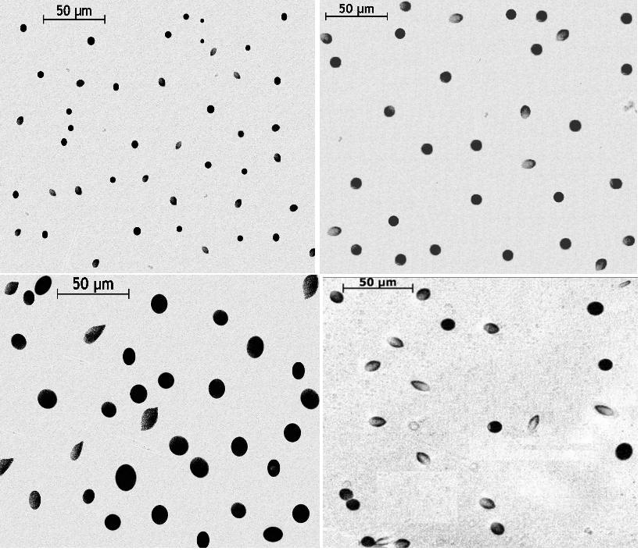

**Figure:** (section heading, 12 pt, caps, bold)

Conclusion:

Conclusion should include main highlights of the results and importance of the work.

References:

1. Author1, Author2, Author3, and Author4; “Title” Journal Name, 272 (2006), 143
2. One, Two and Three, BARC Report No. (Year)