Time Table

March 26, Monday, 2007

6:00 P.M. – 6: 45 P.M. Amitabha Gupta Topic I

6:45 P.M. – 7:00 P.M. TEA BREAK

7:00 P.M. – 7: 45 P.M. Amitabha Gupta Topic I (Contd.)

7: 45 P.M. – 8:00 P.M. Discussion

March 27, Tuesday, 2007

6:00 P.M. – 6: 45 P.M. Amitabha Gupta Topic II

6: 45 P.M. – 7:00 P.M. TEA BREAK

7:00 P.M. – 7: 45 P.M. Amitabha Gupta Topic III

7: 45 P.M. – 8:00 P.M. Discussion

March 28, Wednesday, 2007

6:00 P.M. – 6: 45 P.M. Prajit Basu Topic I

6: 45 P.M. – 7:00 P.M. TEA BREAK

7:00 P.M. – 7: 45 P.M. S. G. Kulkarni Topic I

7: 45 P.M. – 8:00 P.M. Discussion

March 9, Thursday, 2007

6:00 P.M. – 6: 45 P.M. S. G. Kulkarni Topic II

6: 45 P.M. – 7: 00 P.M. TEA BREAK

7: 00 P.M. – 7:45 P.M. Prajit Basu Topic II

7: 45 P.M. – 8:00 P.M. Discussion

March 30, Friday, 2007

6:00 P.M. – 6: 45 P.M. Prajit Basu Topic III

6: 45 P.M. – 7:00 P.M. TEA BREAK

7:00 P.M. – 7: 45 P.M. S. G. Kulkarni Topic III

7: 45 P.M. – 8:00 P.M. Discussion

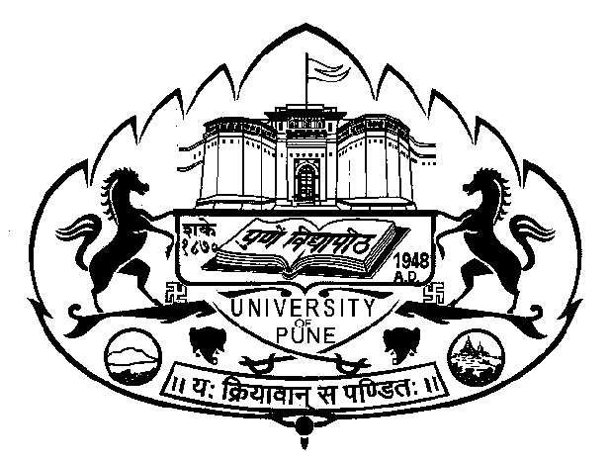
UNIVERSITY OF PUNE
UNIVERSITY WITH POTENTIAL FOR EXCELLENCE (UPE) PROGRAMME

Evening Lecture Series
on
Logic and Science
Explorations into the Methodology of Science
(March 26 – 30, 2007)

The series is designed for Research Students, Teachers, and Scientists. The objective of the series is to expose the audience to Logic and Methodology of Science through examples and Case Studies of important scientific experiments and theories.

Speakers | Topics
Prof. Amitabha Gupta  Visiting Professor under UPE, University of Pune | Topic I: Axiomatic Structure of Scientific Theory and Scientific Modeling: Role of Deduction: Galileo, Newton, Kinetic Theory of Gases, Deductive Logic: Syntactic & Semantic Definition of “following from”; Formal Deductions in Axiomatic and Natural Deduction Systems with properties of Consistency & Completeness
Topic II: Inductive Logic : Mill’s Methods and Discovery of
Argon
 | Topic III: Abductive Logic : Kepler’s Laws
Prof. S.G. Kulkarni,  Central University, Hyderabad | Topic I: Positivists’ Account  Topic II: Popperian Account
 | Topic III: Post-Positivist Account: Kuhn and Feyerabend
Prof. Prajit K. Basu,  Central University, Hyderabad | Topic I: Logic of Experiments in Natural Sciences: An  Introduction
 | Topic II: Chemical Revolution
 | Topic III: The Michelson- Morley Experiment

Venue: Sir C.V. Raman Auditorium, Department of Physics,
University of Pune, Pune 411 007

Dates: March 26, Monday to March 30, Friday, 2007
Time: 6.00 p.m. to 8.00 p.m.
(Daily 2 lectures of 45 mins. Each, with a Tea Break)

Registration: Please register your name with Prof. D.S. Joag,
Department of Physics, University of Pune at the earliest.

The Series has NO registration fees

